Python Codes

1.Generate Factors Of a number

Pro.Code
def print_factors(x):
print("The factors of",x,"are:")
for i in range(1, x + 1):
if x % i == 0:
print(i)
num = 320
print_factors(num)

Output:
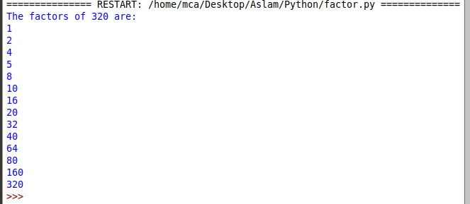
2. Display the given pyramid with step number accepted from user:

Pro.Code
n = int(input("enter the step size:"))
for i in range(1,n+1):
k=i
for j in range(1,i+1):
print(k,end='')
k+=i
print()

Output:
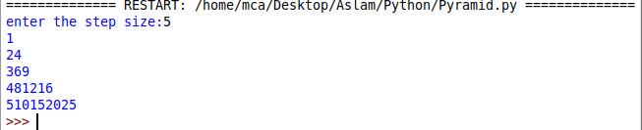

3. Construct Following Pattern
*
**
***
****
*****
****
***
**
*

Pro.Code
n=5
for i in range(n):
for j in range(i):
print('*',end="")
print("")
for i in range(n,0,-1):
for j in range(i):
print('*',end="")
print("")

Output:
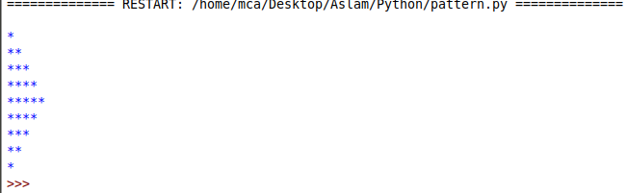
5.Find perfect squres of a 4 digit number

Pro.Code:
import math
for i in range(1000,10000):
num=int(math.sqrt(i))
if num*num==i:
n=i
while n!=0:
r=n%10
n=n/10
if r%2!=0:break
else: print(i)

Output:
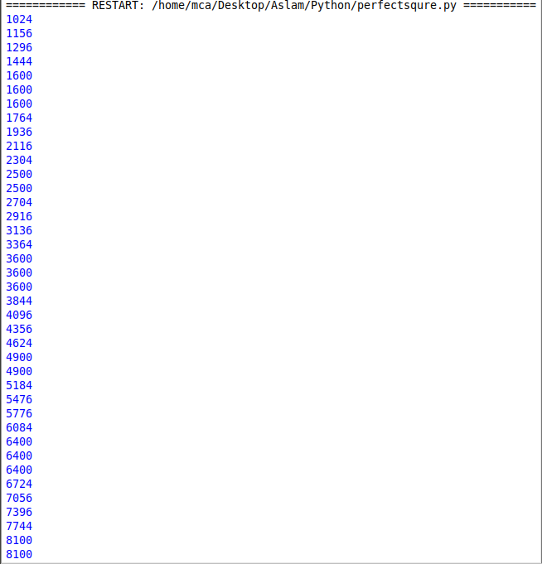

6. Character Frequency

Pro.Code:
dict={}
str1=input("enter a string")
for n in str1:
if n in dict:
dict[n]+=1
else:
dict[n]=1
print("character frequency")
for k,v in dict.items():
print(k,v)

Output:
